# Compass Worksheet

The first step in building your compass is to plan the algorithm. You will use a flow chart to do this. Use the following rules to help you:

* + **If** the compass heading is less than 45 degrees or more than 315 degrees **then** you are pointing North
  + **If** the compass heading is less than 135 degrees **then** you are pointing East
  + **If** the compass heading is less than 225 degrees **then** you are point South
  + **Else** you are pointing West

You should use a parallelogram to represent the input which is the compass heading.

You should then add in any decisions using a diamond shape. Remember to label the arrows coming out of the diamond to show when to take each branch.

You should use a process to display the direction that you are heading. The first steps have been completed for you.

Start

Input heading

You are pointing North

Heading less than 45 degrees or more than 315 degrees?

Yes

Now that you have planned your algorithm you can now program your micro:bit.

Visit the MakeCode website. <https://makecode.microbit.org/#editor>

The first step is to create a new variable to store the compass heading. Click on the **Variables** block and then click on **Make a Variable.**



You will see a dialogue box appear where you can type in the name of your variable. Create a new variable called *Degrees* and click on ok.



You will then see a number of options appear in the **Variables** group.



Drag the ***set degrees*** block inside of the ***forever*** loop.



At the moment it will always set *Degrees* to 0. As we want it to read the compass heading you need to click on the **Input** group and then select the ***compass heading*** option.



You should then drag the ***compass heading*** so that it appears instead of the 0.



Using the **Logic** category, you should now build your first ***if*** statement.

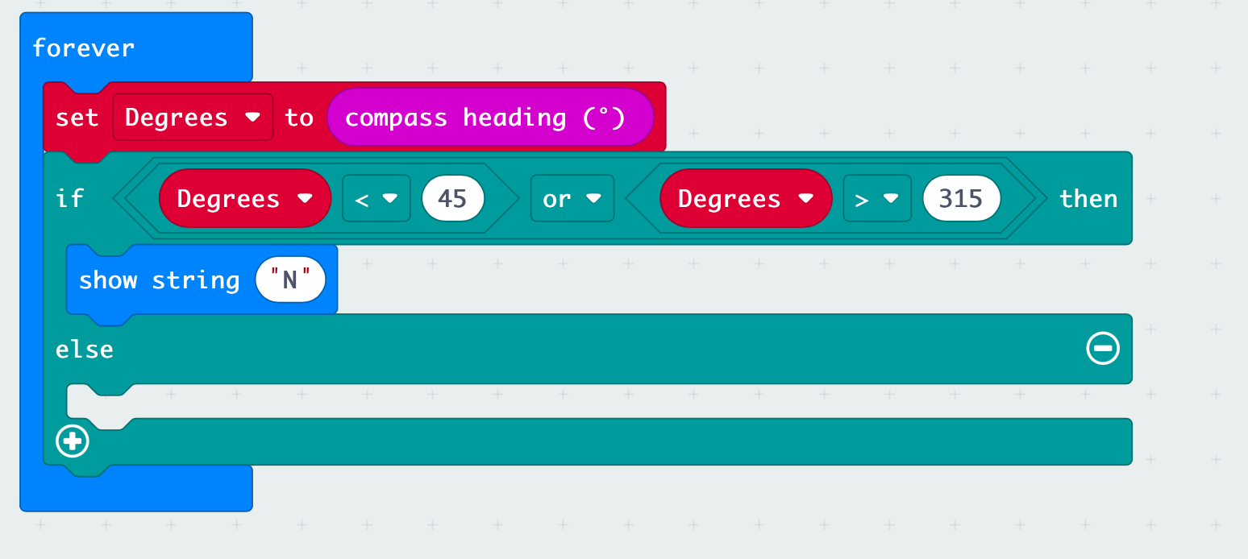

You now need to continue to add additional options for the four directions, North, South, East and West.

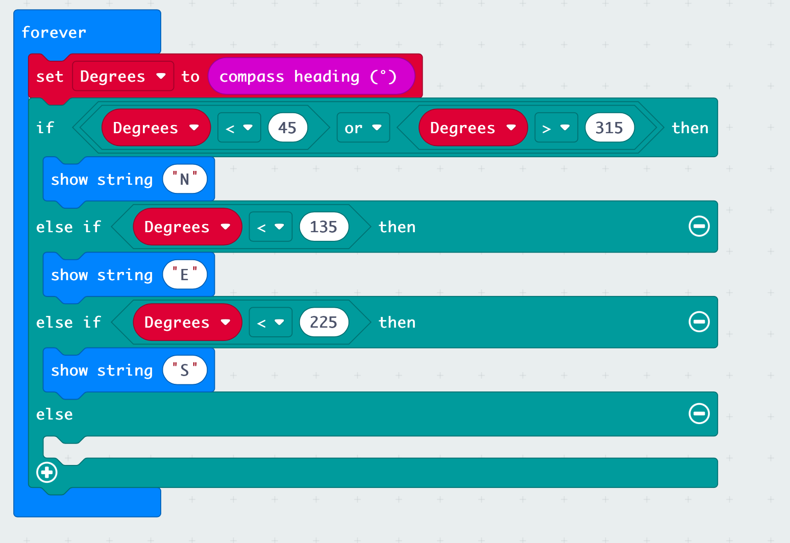

For any other reading the direction will be West. Add this under the else block.

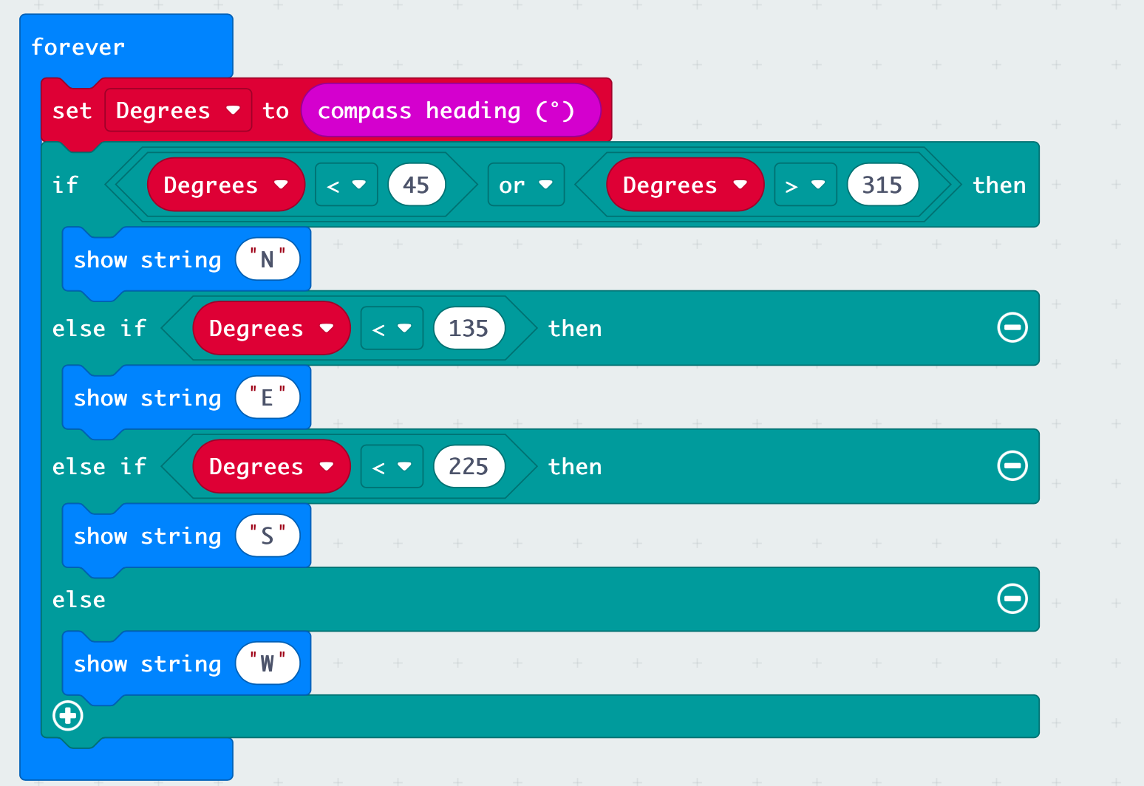

Congratulations, you have now developed your own compass using the micro:bit.

# Adding Sound

Version 2 of the mico:bit has a built in speaker. To activate the speaker add the set built-in speaker block to on in the On Start loop.

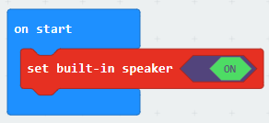

You can then add a different sound to each branch in the IF statement.

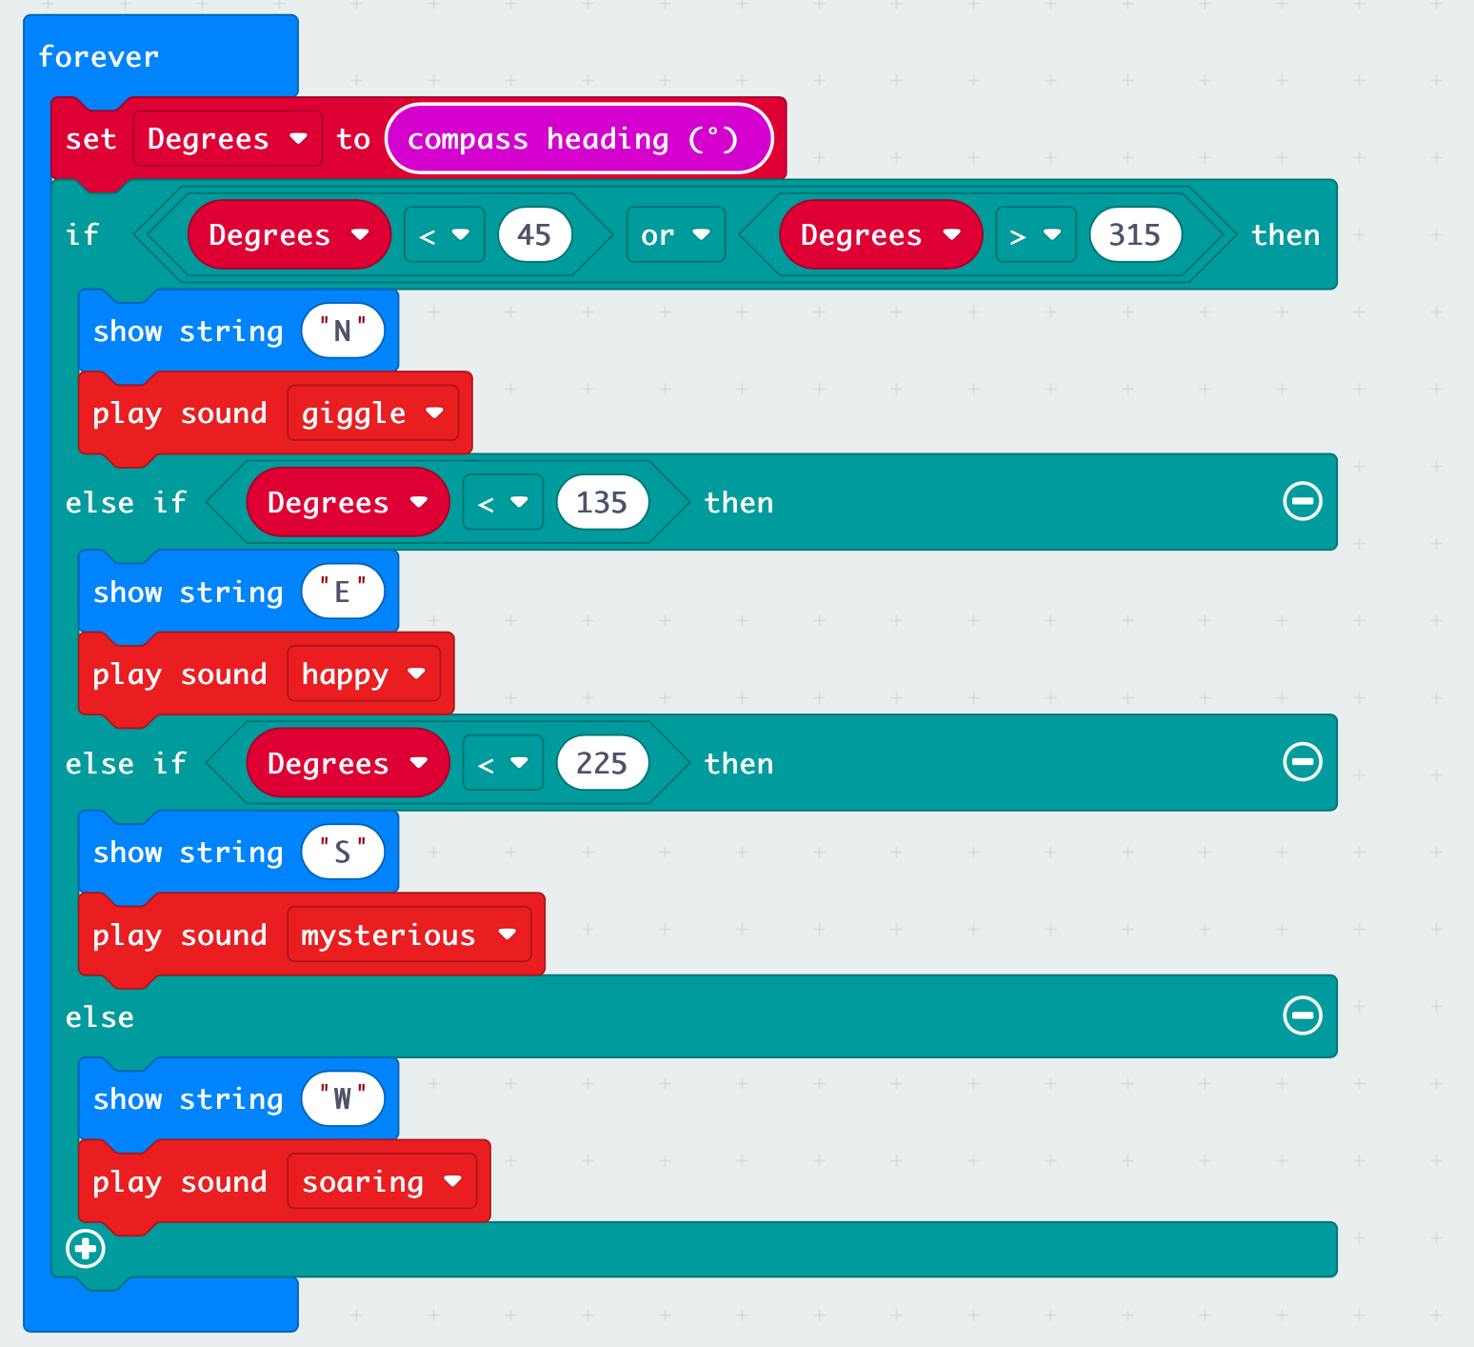

# Stretch Task

Can you add further options to cover additional directions? Try to develop your code to also include: North East, South East, South West and North West.